|  |  |
| --- | --- |
|  |  |
|  | |

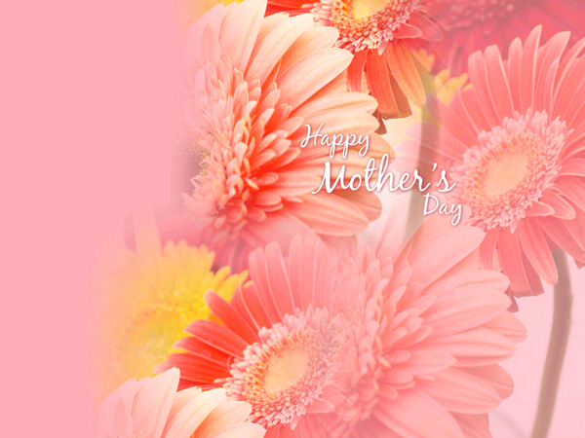

* Thanks for teaching me right from wrong
* For speaking to me lovingly
* For always forgiving me

This tribute is for your, mom, because of all the ways you have showed me how to live

**Thank You Mother**